**Developed CMS Site**

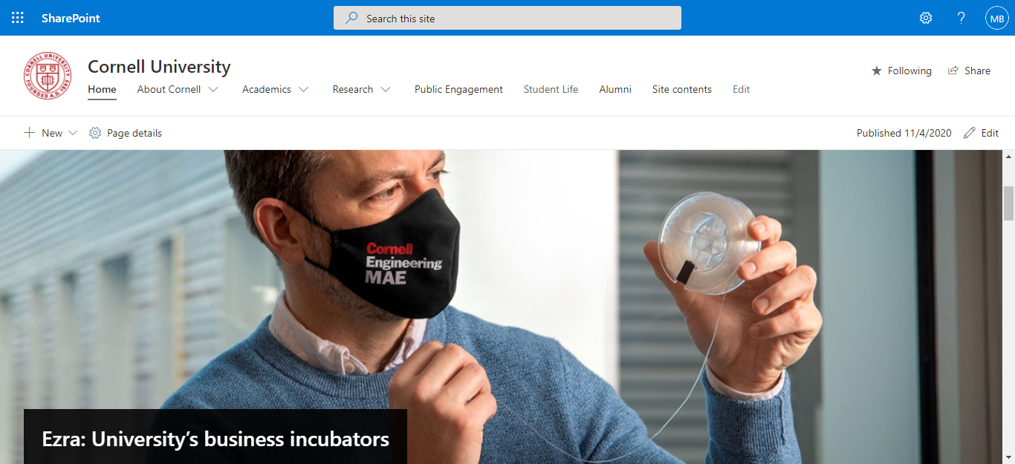

This is the home page where everyone can show everything

Figure 1: Home Page

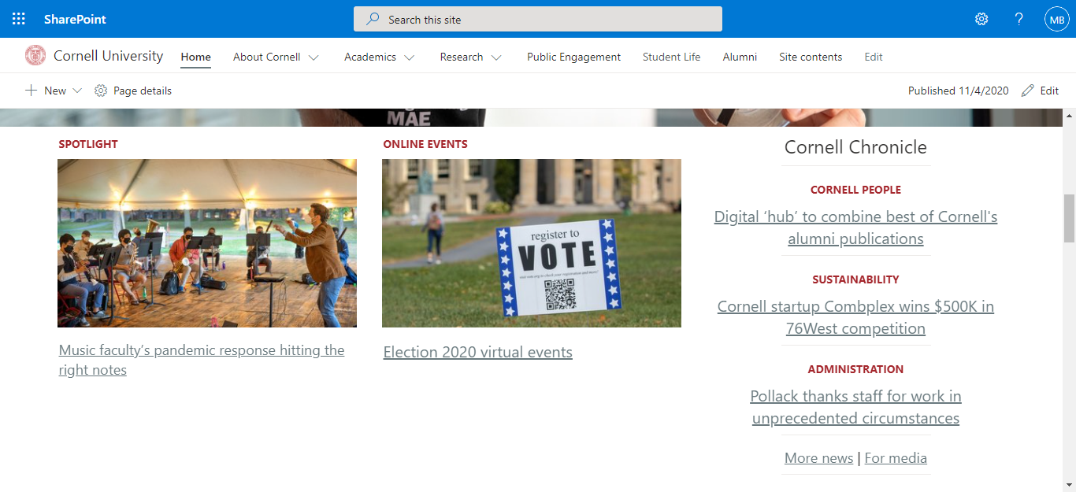

Figure-2: Rest of the Home Page

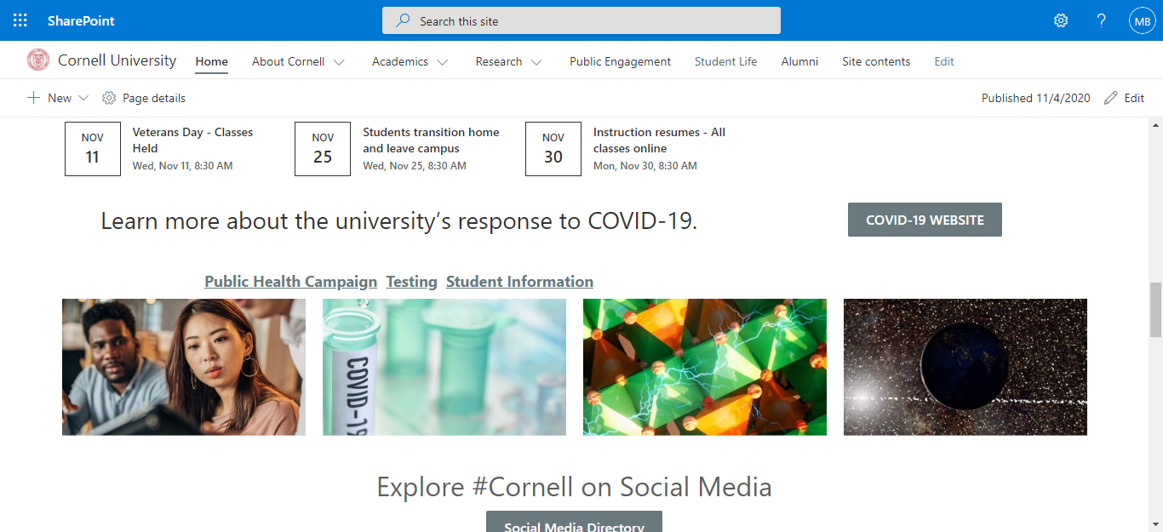

Figure-3: Rest of the Home Page

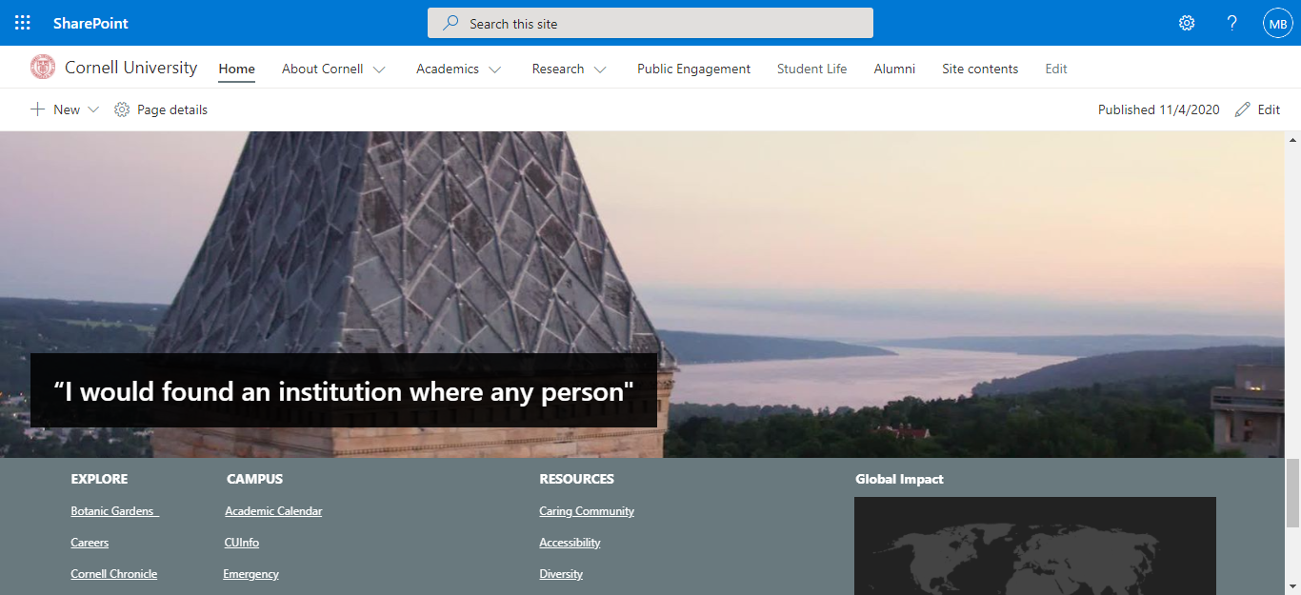

Figure-4: End of the Home Page

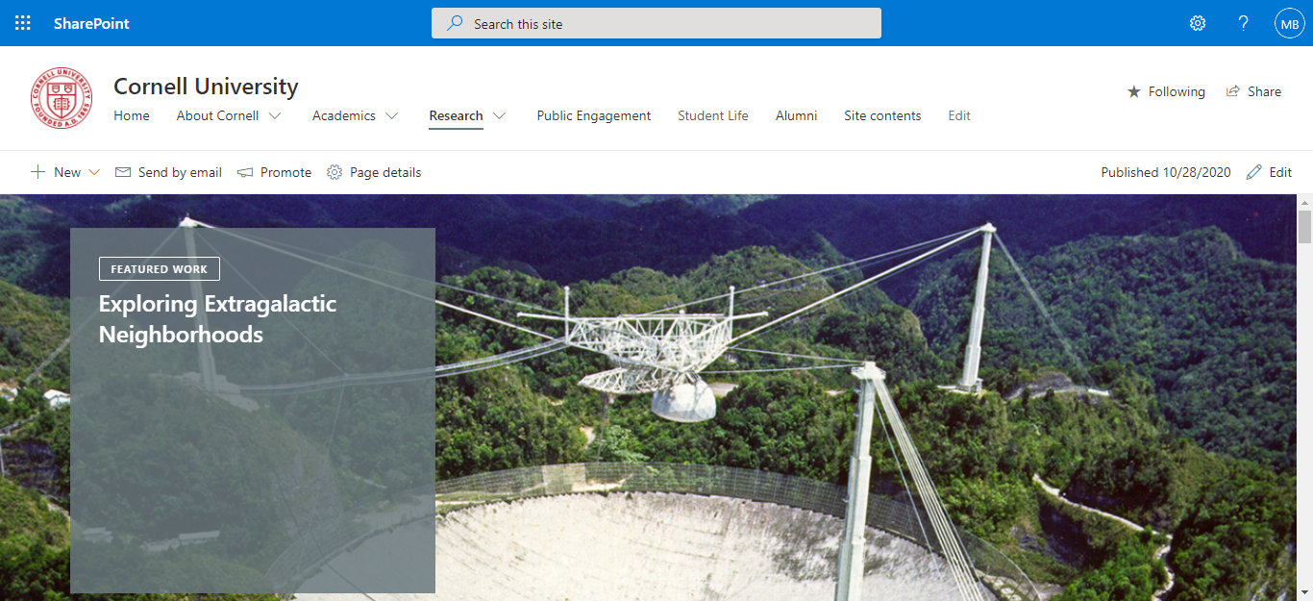

In this research page student can find all research paper for any documents or project.

Figure-5: Research Page

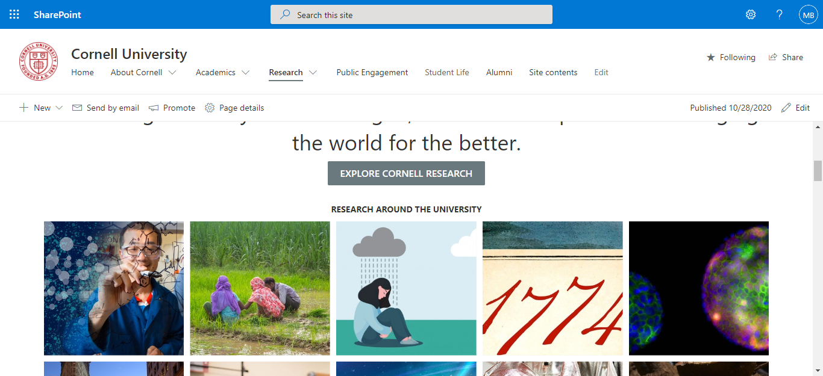

Figure-6: Rest of the Research Page

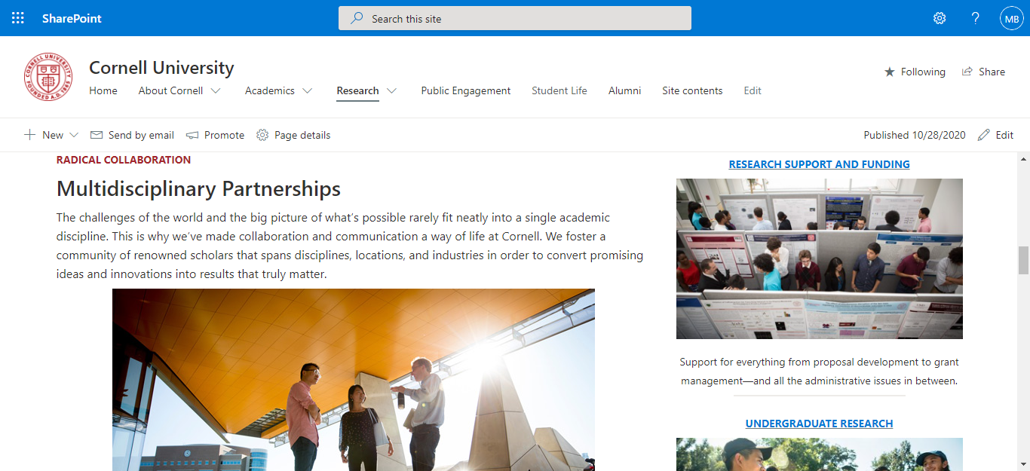

Figure-7: Research Page

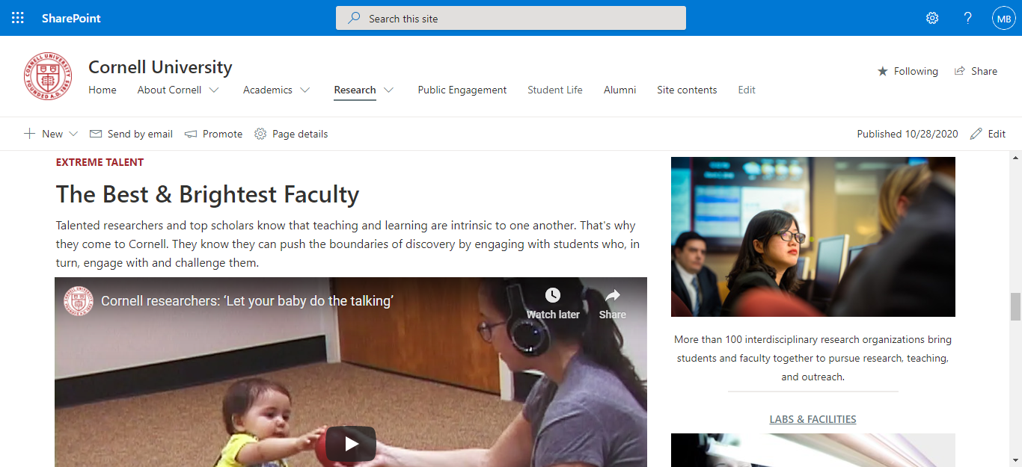

Figure-8: Rest of the Research Page

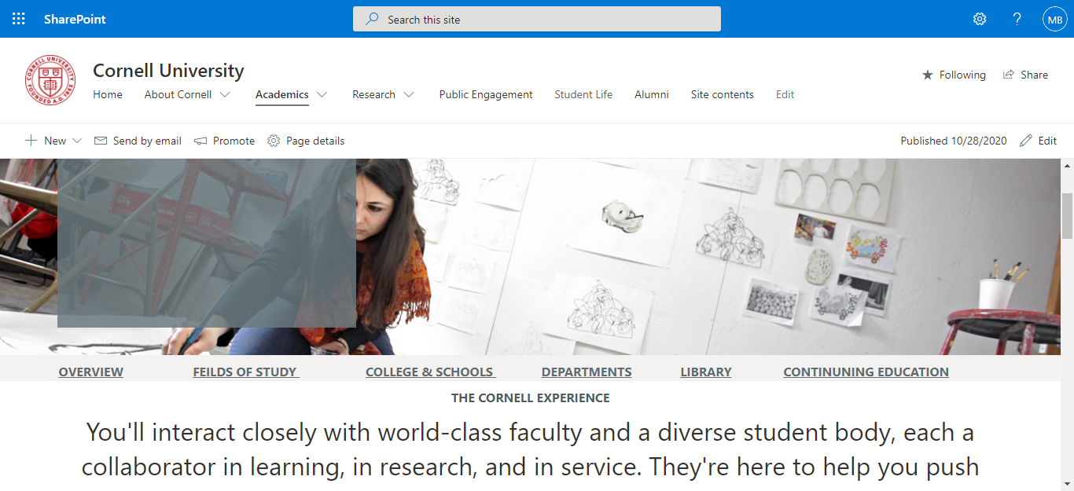

This is the academic page where anyone can find any kind of information about the university

Figure-9: Academics Page

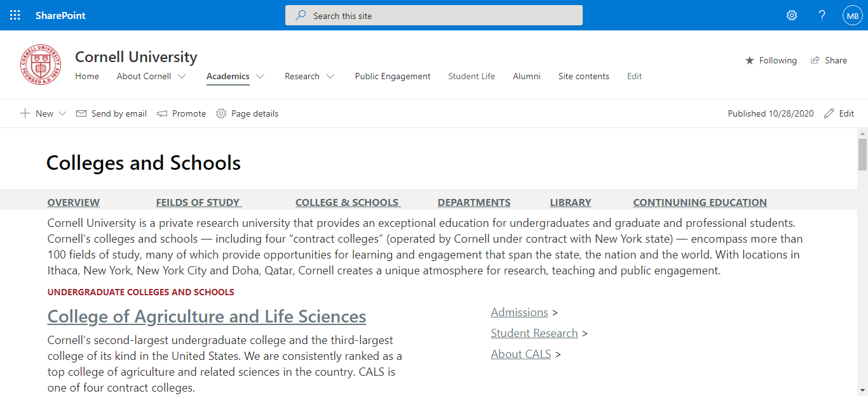

College and school information

Figure- 10: School College information.

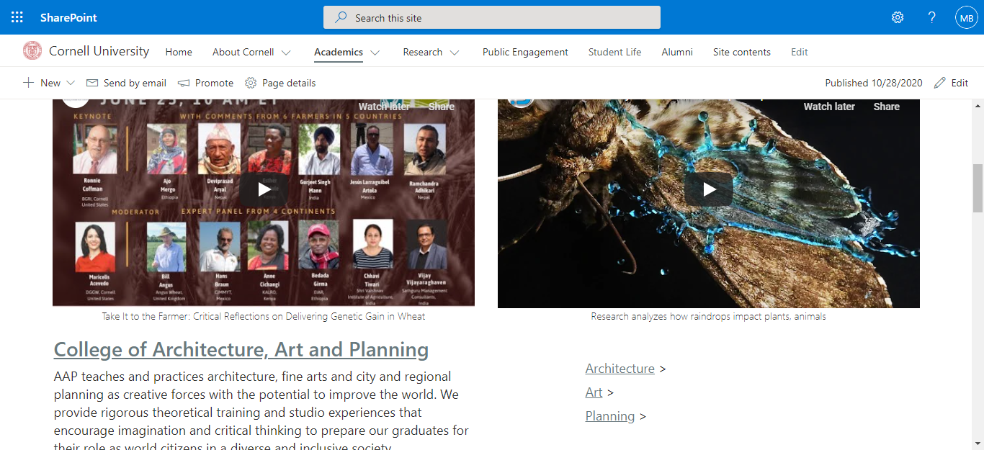

Figure- 11: School College information.

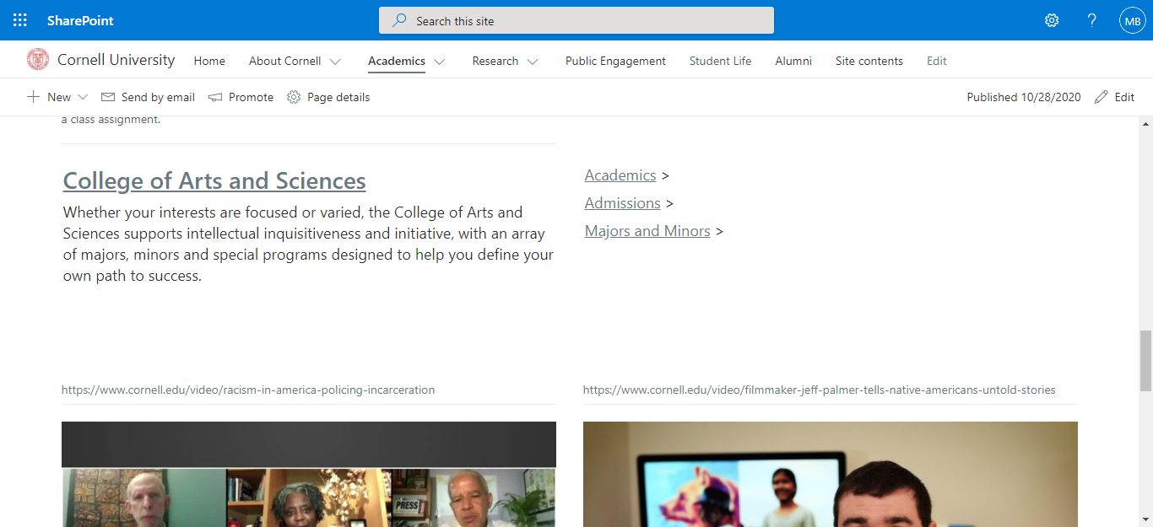

Figure- 12: School College information.

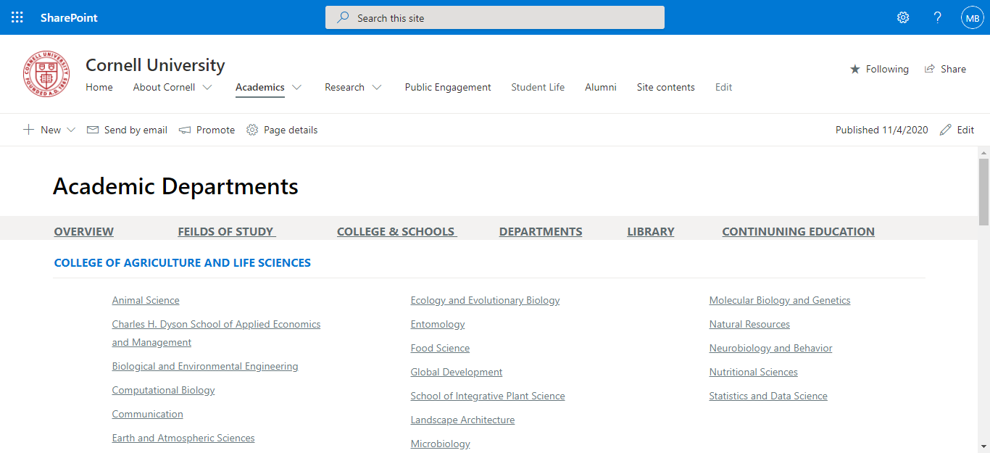

Department information

Figure- 13: Department

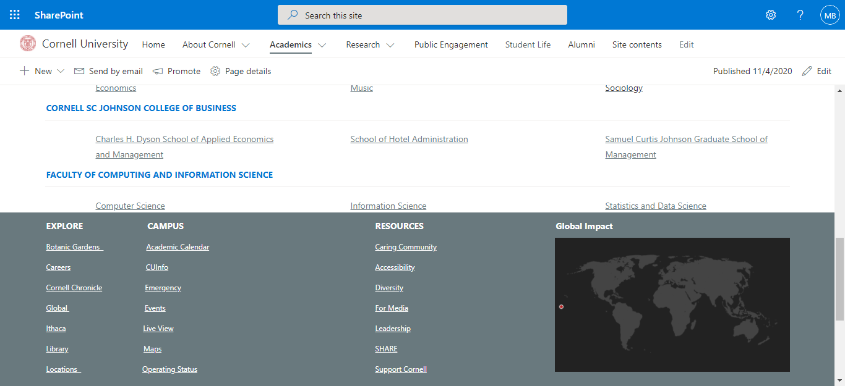

Figure- 14: Rest of Department

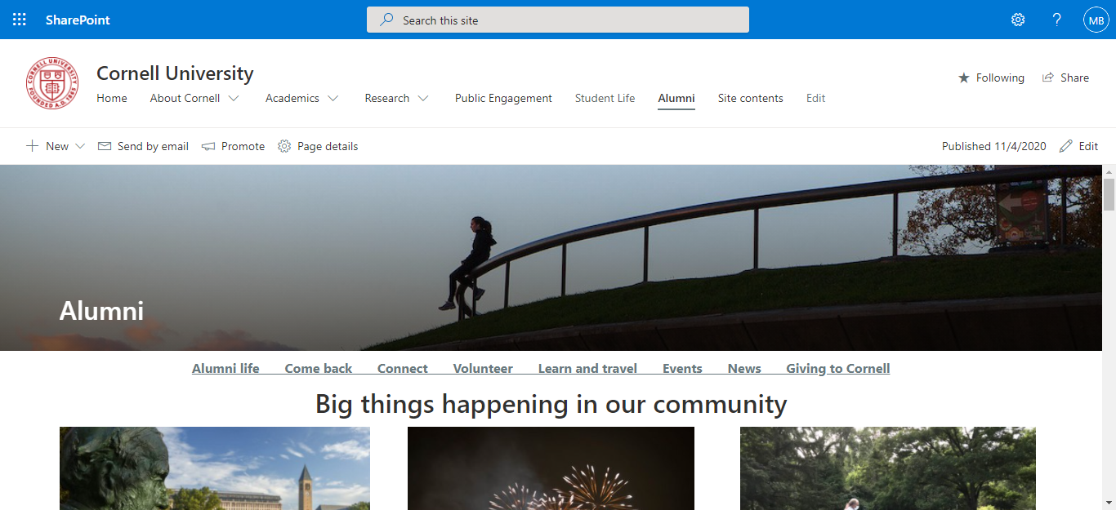

This is the alumni page all the previous students’ details is here

Figure- 15: Alumni

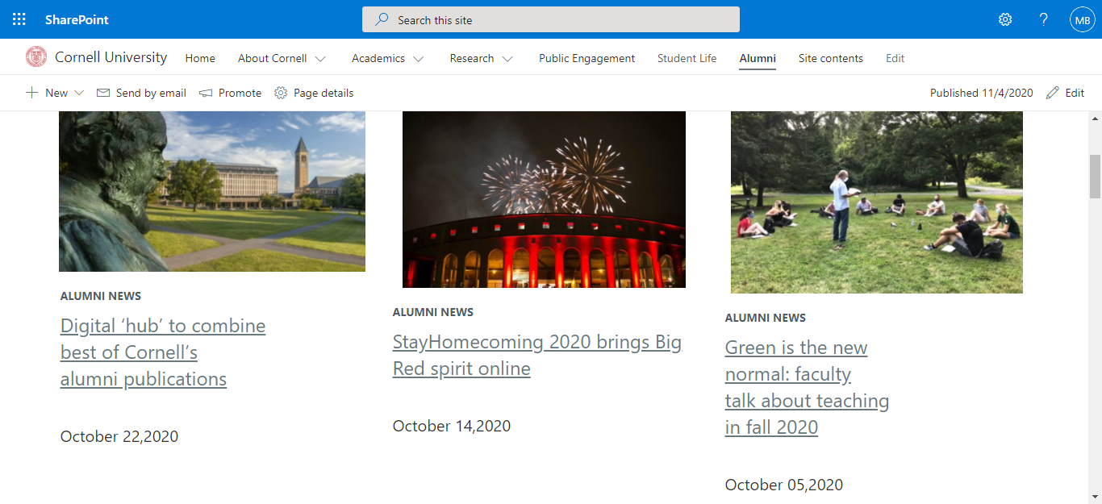

Figure- 17: Alumni News

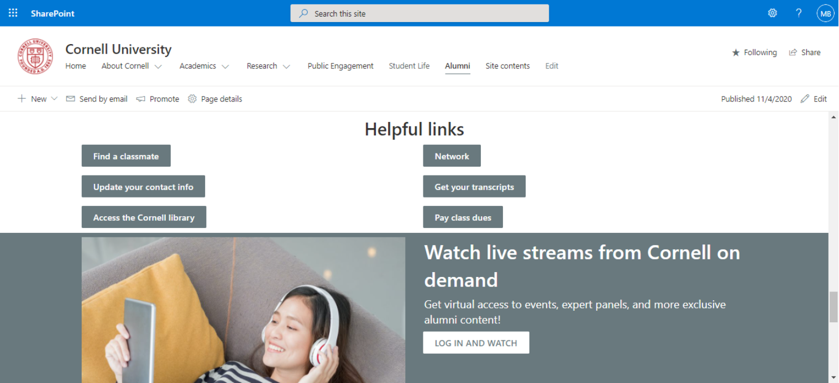

Figure- 18: End of Alumni

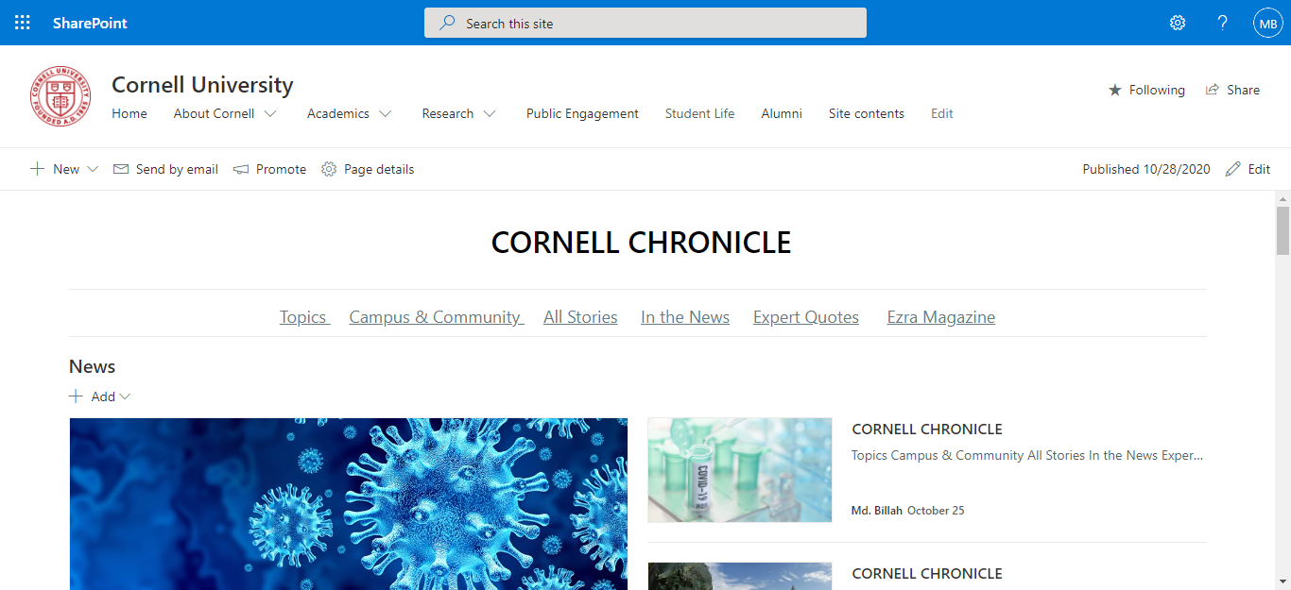

Student can see the hole news of the university.

Figure- 19: Cornell News

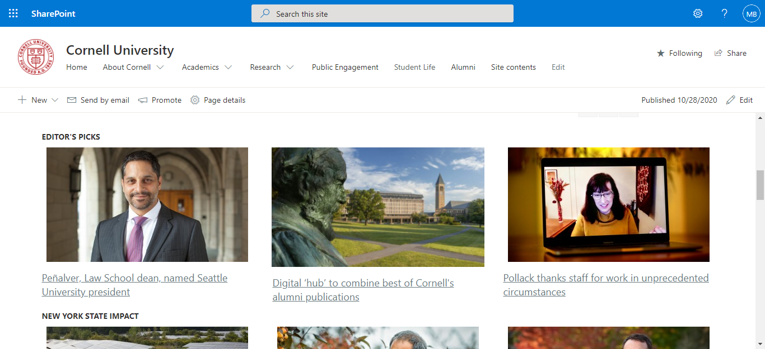

Figure- 20: Cornell News part 2

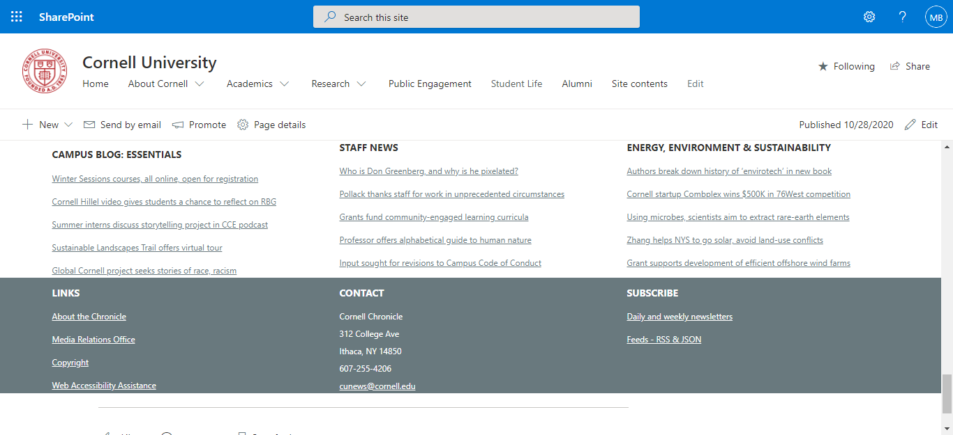

Figure- 21: Rest of Cornell News

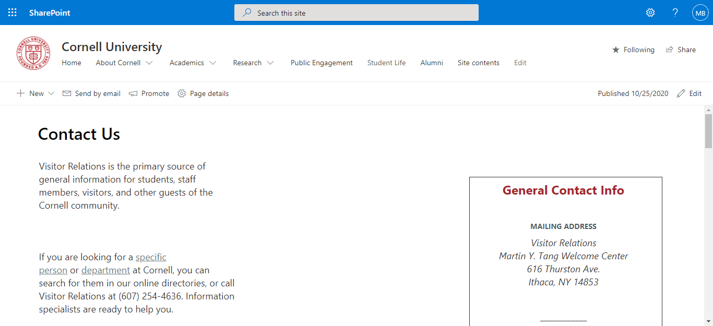

Student can contact with the helpful number or address

Figure- 22: Contact us

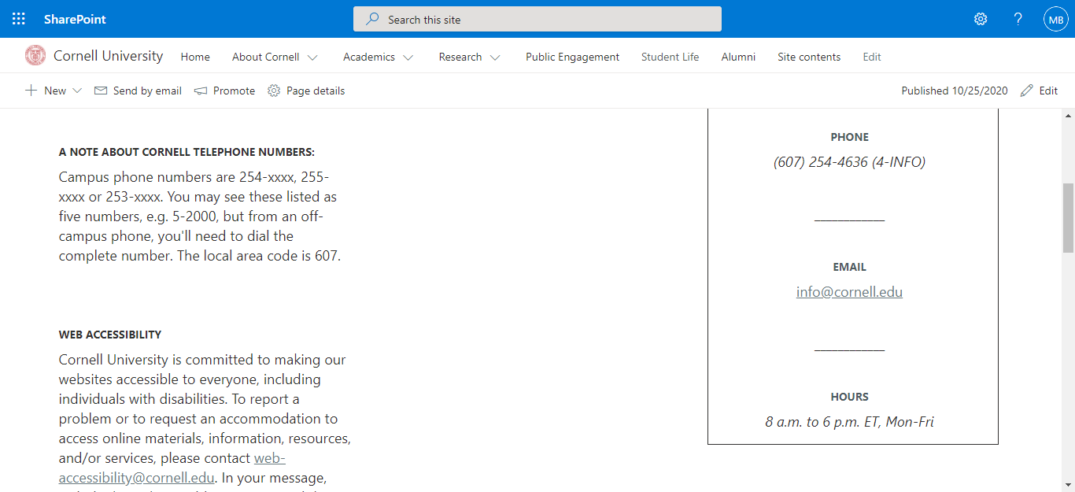

Figure- 23: Contact us Page

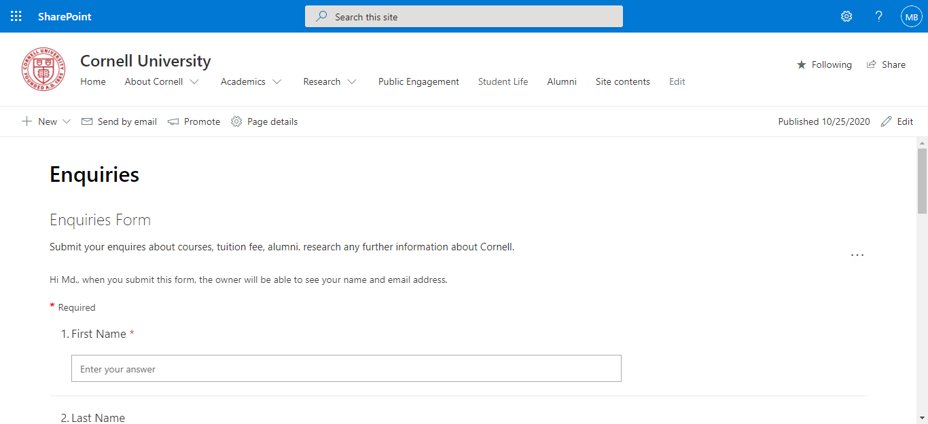

Those who need any kind of inquire or FAQ ,they would contact the authority with the inquiry form.

Figure- 24: Enquiry

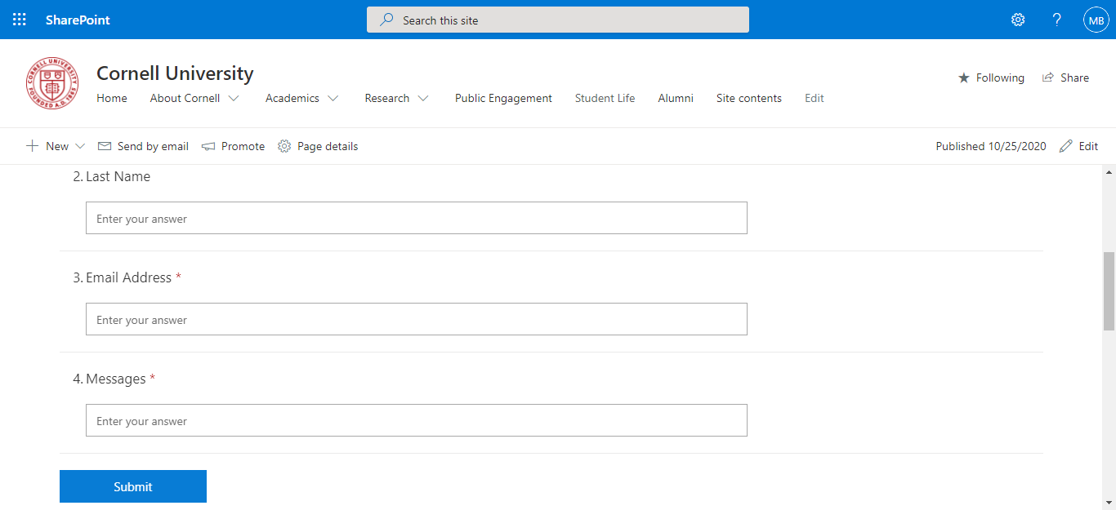

Figure- 25: Enquiry form